*October 15, 2023. Andrea Barreto, Chief Data Scientist*

**School District’s Data Analysis Report**

**Overview**

Merging the information from all the schools and students’ data, an analysis was made in order to help the school board and mayor make strategic decisions regarding future school budgets and priorities.

**Data and Model**

At first, the district-wide standardized test results were analyzed. There was access to every student's math and reading scores, as well as various information on the schools they attend. The data was aggregated to showcase obvious trends in school performance.

Information tables were created for an easier understanding of the data.

**Results**

* District's key metrics:



* Schools Summary:

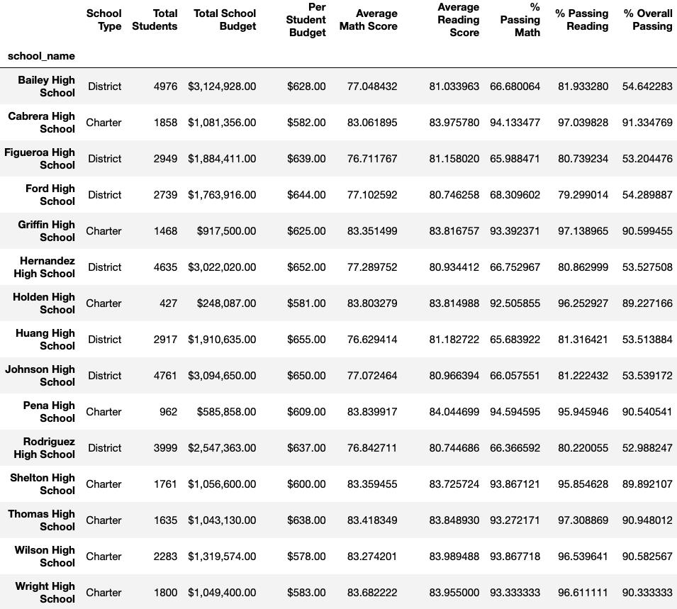

* Highest-Performing Schools (by % Overall Passing):

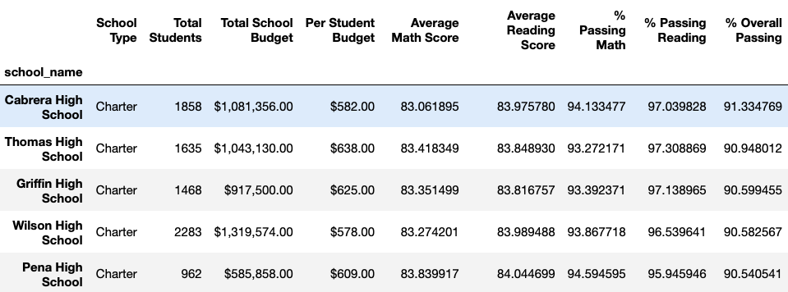

* Bottom Performing Schools (By % Overall Passing);

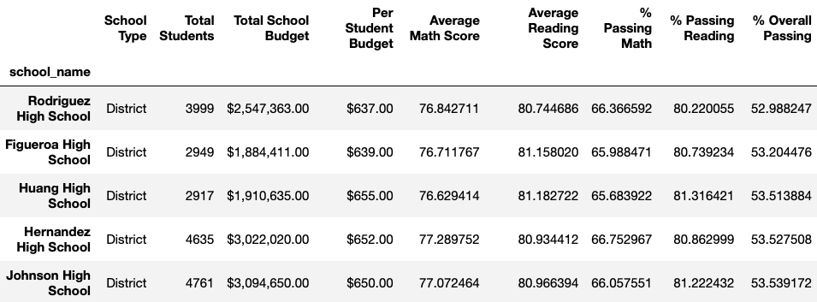

## Math Scores by Grade:

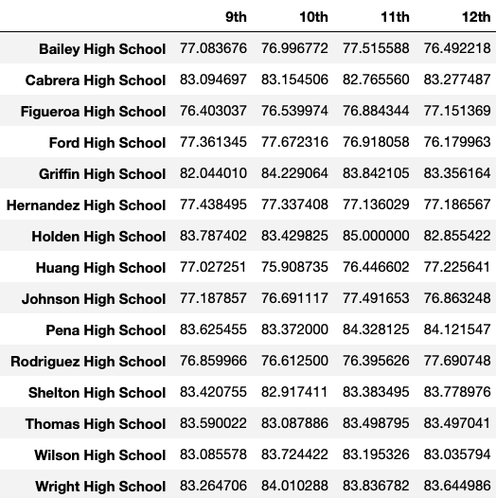

## Reading Score by Grade:

## 

## Scores by School Spending:

## 

## Scores by School Size:

## 

## Scores by School Type:

## 

## Conclusions

## There are 15 schools in the district with a total of 39,170 students. The District school budget is $24,649,428. Students do better on the reading test than they do in math. They get an average score on the math test of 78.98 and only 74.98% of the students actually pass the test, while in the reading test the average score is 81.87 and 85.80% of the students actually pass the test. Overall 65% of the students can pass both tests.

## Charter schools have a higher performance than district schools, the top 5 best performing school’s in the district are charter schools with overall passing percentages of 90% or more, and the bottom five are actually district schools with an overall passing percentage of less than 54%.

## Students in schools with lower spending per students budget are more likely to pass the test. By looking at the *Scores by School Spending* table it can be observed that schools spending less than $585 per student have an overall passing percentage of 90% while the schools that spend $645 to $680 per students have an overall passing percentage of 53%.

## Schools should be limited to 2,000 or less students. The Scores by School Size table clearly showcases that small and medium size schools have a better performance with 90$ passing both tests while in larger schools with more than 2,000 students only 58% of the students actually pass both tests.

## Charter schools perform better than district schools. 90% of students in charter schools pass both tests while in district schools is only 53% of the students.